Introduction to Operating System

1.1 Introduction to Operating System
An operating system is a program that acts as an interface between the user and the computer hardware which manages and controls the execution of all kinds of programs. An Operating System is the software that tells a computer how to operate. It controls hardware, executes programs, manages tasks and resources, and provides the user with an interface to the computer.
In other words, OS is defined as a program or suit (support for) of programs that controls the entire operation of the computer, such as recognizing input from keyboard, sending output to the display screen keeping track of files and directories on the disk and controlling peripheral devices such as disk drives. All modern computing devices including Laptops, Tablet, mobile phones, etc. comprise an Operating System which helps in the smooth working of the device.
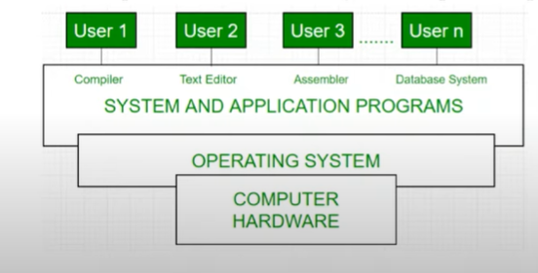

History of the Operating System
It took years to evolve the Operating Systems and make them as modernized and advanced as they are today. Given below are the details about the evolution and history of Operating systems.
- Initially, the computers made did not have an Operating system and to run each program a different code was used. This had made the processing of data more complex and time taking
- In 1956, the first operating systems were developed by General Motors to run a single IBM computer
- It was in the 1960s that IBM had started installing OS in the devices they launched
- The first version of the UNIX operating system was launched in the 1960s and was written in the programming language C
- Later on, Microsoft came up with their OS on the request of IBM
- Today, all major computer devices have an operating system, each performing the same functions but with slightly different features

Internal Structure of OS
The organization of operating system deal with the internal structure of OS, mainly it is divided into 3 layers as shown in figure below:
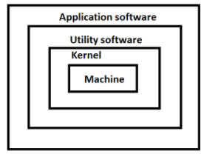

- OS Kernel: A main part of OS always remains in main memory during the running of a computer, called OS Kernel. It is main controlling part of OS which controls all running programs and the hardware resources. It can directly communicate with hardware as well as the upper layers.
- Utility Software: Outside this layer, there is a set of utility programs which are used as system management tools, also known as housekeeping works of OS. The main purpose of these tools is to make system up-to-date and efficient. Example: scandisk, disk-cleanup, disk management
- Application software: Application software is developed in order to fulfill the user requirements. Different application is available in the market as readymade software. Some of them are developed on the user's demand called tailored software. Example: Notepad, WordPad, Paint, etc.

1.2 Functions of an Operating System
- I/O Management
One of the important jobs of an Operating System is to manage various I/O devices including mouse, keyboards, touch pad, disk drives, display adapters, USB devices, Bit-mapped screen, LED, Analog-to-digital converter, On/off switch, network connections, audio I/O, printers etc.
An I/O system is required to take an application I/O request and send it to the physical device, then take whatever response comes back from the device and send it to the application.

- Memory Management
Memory is the large array of words or bytes, each with its own address. When user requests CPU for read/write operation, OS determines the amount of memory required for the program instructions and data. Then, OS allocates required memory to load the program and data into RAM. When program terminates its memory area is free and the same memory area is allocated for other programs.

- Processor Management
In a multi programming environment, the OS decides the order in which processes have access to the processor, and how much processing time each process has. This function of OS is called process scheduling. An Operating System performs the following activities for processor management. Keeps tracks of the status of processes. The program which perform this task is known as traffic controller. Allocates the CPU that is processor to a process. De-allocates processor when a process is no more required.

- File Management –
A file system is organized into directories for efficient or easy navigation and usage. These directories may contain other directories and other files. An Operating System carries out the following file management activities. It keeps track of where information is stored, user access settings and status of every file and more… These facilities are collectively known as the file system.

- Device Management –
An OS manages device communication via their respective drivers. It performs the following activities for device management. Keeps tracks of all devices connected to system. designates a program responsible for every device known as the Input/Output controller. Decides which process gets access to a certain device and for how long. Allocates devices in an effective and efficient way. Deallocates devices when they are no longer required.

Other function of OS is mentioned below:
- Security –
The operating system uses password protection to protect user data and similar other techniques. It also prevents unauthorized access to programs and user data.
- Control over system performance –
Monitors overall system health to help improve performance. Records the response time between service requests and system response to have a complete view of the system health. This can help improve performance by providing important information needed to troubleshoot problems.
- Job accounting –
Operating system Keeps track of time and resources used by various tasks and users, this information can be used to track resource usage for a particular user or group of user.
- Error detecting aids –
Operating system constantly monitors the system to detect errors and avoid the malfunctioning of computer system.
- Coordination between other software and users –
Operating systems also coordinate and assign interpreters, compilers, assemblers and other software to the various users of the computer systems.

1.3 Types of an Operating System

1.3.1 Based On Processing Method

Batch Operating System
This type of operating system does not interact with the computer directly. There is an operator which takes similar jobs having the same requirement and group them into batches. It is the responsibility of the operator to sort jobs with similar needs.
Advantages of Batch Operating System:
- It is very difficult to guess or know the time required for any job to complete. Processors of the batch systems know how long the job would be when it is in queue
- Multiple users can share the batch systems
- The idle time for the batch system is very less
- It is easy to manage large work repeatedly in batch systems
Disadvantages of Batch Operating System:
- The computer operators should be well known with batch systems
- Batch systems are hard to debug
- It is sometimes costly
- The other jobs will have to wait for an unknown time if any job fails
Examples of Batch based Operating System: Payroll System, Bank Statements, etc.
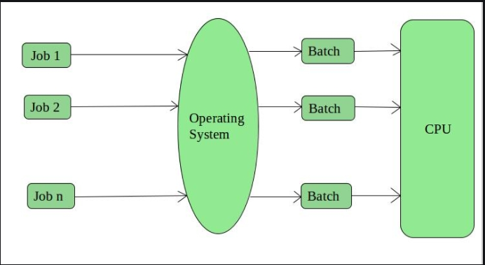
Time-Sharing Operating Systems –
Each task is given some time to execute so that all the tasks work smoothly. Each user gets the time of CPU as they use a single system. These systems are also known as Multitasking Systems. The task can be from a single user or different users also. The time that each task gets to execute is called quantum. After this time interval is over OS switches over to the next task.
Advantages of Time-Sharing OS:
- Each task gets an equal opportunity
- Fewer chances of duplication of software
- CPU idle time can be reduced
Disadvantages of Time-Sharing OS:
- Reliability problem
- One must have to take care of the security and integrity of user programs and data
- Data communication problem
Examples of Time-Sharing OSs are: Multics, Unix, etc.

Multiprocessing Operating System
Multiprocessor/Multiprocessing Operating System refers to the use of two or more central processing units (CPU) within a single computer system. In other words, in operating systems, to improve the performance of more than one CPU can be used within one computer system called Multiprocessor operating system.
Multiple CPUs are interconnected so that a job can be divided among them for faster execution. When a job finishes, results from all CPUs are collected and compiled to give the final output. Jobs needed to share main memory and they may also share other system resources among themselves. Multiple CPUs can also be used to run multiple jobs simultaneously.
For Example: UNIX
Operating system is one of the most widely used multiprocessing systems.
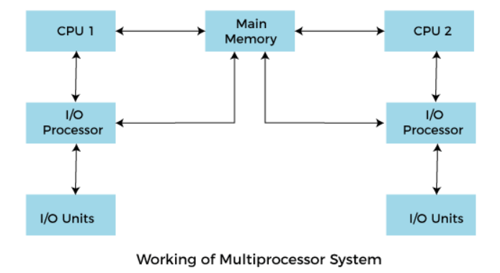
To employ a multiprocessing operating system effectively, the computer system must have the following things:
- A motherboard is capable of handling multiple processors in a multiprocessing operating system.
- Processors are also capable of being used in a multiprocessing system.

Advantage of Multiprocessing Operating System
- Increased reliability:
Due to the multiprocessing system, processing tasks can be distributed among several processors. This increases reliability as if one processor fails; the task can be given to another processor for completion.
- Increased throughout:
As several processors increase, more work can be done in less
- The economy of Scale:
As multiprocessors systems share peripherals, secondary storage devices, and power supplies, they are relatively cheaper than single-processor systems.

Disadvantages of Multiprocessing operating System
- Operating system of multiprocessing is more complex and sophisticated as it takes care of multiple CPUs at the same time.
Multitasking Operating System
Multitasking, in an operating system, is allowing a user to perform more than one computer task (such as the operation of an application program) at a time. The operating system is able to keep track of where you are in these tasks and go from one to the other without losing information. Microsoft Windows 2000, IBM's OS/390, and Linux are examples of operating systems that can do multitasking (almost all of today's operating systems can). When you open your Web browser and then open Word at the same time, you are causing the operating system to do multitasking. Being able to do multitasking doesn't mean that an unlimited number of tasks can be juggled at the same time. Each task consumes system storage and other resources. As more tasks are started, the system may slow down or begin to run out of shared storage.
Real Time Operating System
Real-time operating systems (RTOS) are used in environments where a large number of events, mostly external to the computer system, must be accepted and processed in a short time or within certain deadlines. such applications are industrial control, telephone switching equipment, flight control, and real-time simulations. Such system with RTOS works within a time-bound and has a fixed deadline. The processing in this type of system must occur within the specified constraints. Otherwise, this will lead to system failure.
Examples of the real-time operating systems: Airline traffic control systems, Command Control Systems, Airline’s reservation system, Heart Peacemaker, Network Multimedia Systems, Robot etc.
The real-time operating systems can be of 2 types –
- Hard Real-Time operating system:
These operating systems guarantee that critical tasks be completed within a range of time.
For example, a robot is hired to weld a car body. If the robot welds too early or too late, the car cannot be sold, so it is a hard real-time system that requires complete car welding by robot hardly on the time.
- Soft real-time operating system:
This operating system provides some relaxation in the time limit.
For example – Multimedia systems, digital audio systems etc. Explicit, programmer-defined and controlled processes are encountered in real-time systems. A separate process is changed with handling a single external event. The process is activated upon occurrence of the related event signaled by an interrupt.
Multitasking operation is accomplished by scheduling processes for execution independently of each other. Each process is assigned a certain level of priority that corresponds to the relative importance of the event that it services. The processor is allocated to the highest priority processes.
Advantages:
The advantages of real-time operating systems are as follows-
- Maximum consumption –
Maximum utilization of devices and systems. Thus more output from all the resources.
- Task Shifting –
Time assigned for shifting tasks in these systems is very less. For example, in older systems, it takes about 10 microseconds. Shifting one task to another and in the latest systems, it takes 3 microseconds.
- Focus On Application –
Focus on running applications and less importance to applications that are in the queue.
- Error Free –
These types of systems are error-free.
- Memory Allocation –
Memory allocation is best managed in these types of systems.
Disadvantages:
The disadvantages of real-time operating systems are as follows-
- Limited Tasks –
Very few tasks run simultaneously, and their concentration is very less on few applications to avoid errors.
- Use Heavy System Resources –
Sometimes the system resources are not so good and they are expensive as well.
- Complex Algorithms –
The algorithms are very complex and difficult for the designer to write on.
- Thread Priority –
It is not good to set thread priority as these systems are very less prone to switching tasks.
- Minimum Switching – RTOS performs minimal task switching.
Like

Distributed Operating System
A distributed operating system (DOS) is an essential type of operating system. Distributed systems use many central processors to serve multiple real-time applications and users. As a result, data processing jobs are distributed between the processors.
It connects multiple computers via a single communication channel. Furthermore, each of these systems has its own processor and memory. Additionally, these CPUs communicate via high-speed telephone lines. Individual systems that communicate via a single channel are regarded as a single entity. They're also known as loosely coupled systems.

Advantages
- With resource sharing facility, a user at one site may be able to use the resources available at another.
- Speedup the exchange of data with one another via electronic mail.
- Failure of one site in a distributed system doesn’t affect the others, the remaining sites can potentially continue operating.
- Better service to the customers.
- Reduction of the load on the host computer.
- Reduction of delays in data processing.

Disadvantages of Distributed OS
- The cost for set up is more.
- Failure of the main system will affect the whole system.
- Programming is complex.

1.3.2 Based on User Interface
The user interface (UI) is the point of human-computer interaction and communication in a device. User interface is the first impression of a software system from the user’s point of view. Therefore, any software system must satisfy the requirement of user. Any device’s operating system is nothing but an interface between the hardware components and its user. The operating system enables the interaction between the user and the device. It does this by providing two user interfaces:
- Command user Interface
- Graphical user Interface
Command User Interface
CLI is a text-based or console representation whereby users type commands into a terminal to navigate or operate devices or software. CLI was the standard way of interacting with computing devices in the early days of computing. Command line interface is a type of UI that enables the users to interact with the operating system by issuing some specific commands. In order to perform a task in this interface, the user needs to type a command at the command line. The disadvantages of the CLI is that the user needs to remember a lot to interact with the operating system.
Graphical User Interface
The graphical user interface, developed in the late 1970s by the Xerox Palo Alto research laboratory and deployed commercially in Apple’s Macintosh and Microsoft’s Windows operating systems, was designed as a response to the problem of inefficient usability in early, text-based command-line interfaces for the average user. Graphical user interfaces would become the standard of user-centered design in software application programming, providing users the capability to intuitively operate computers and other electronic devices through the direct manipulation of graphical icons such as buttons, scroll bars, windows, tabs, menus, cursors, and the mouse pointing device.
Some advantages of GUI based operating system
- The GUI interface is easy to understand and even the new users can operate on them on their own.
- The GUI interface visually acknowledges and confirms each type of activities performed by the users. For example, when the user deletes a file in the Windows operating system, then the operating system asks for the confirmation before deleting it.
- The GUI interface enables the users to perform several tasks at the same time. These features of the operating system are also known as multitasking.

Based on Mode of user

Single user/ Single-Tasking operating system
Single user operating system is also known as “Single Tasking Operating System”, and single user operating system is designed especially for using on the home computers. Single user operating system allows the permission for accessing your personal computer at a time by single user, but some time it can support multiple profiles. Single user operating system is used in the officially work and other environment as well. Functions like printing a document, downloading images, etc., can be performed only one at a time. Examples include MS-DOS, Palm OS, etc.
Single user/multi-Tasking operating system
An operating system that allows a single user to perform more than one task at a time is called Single-User Multitasking Operating System. Examples include Microsoft Windows and Macintosh OS.

Multiuser operating system
A multiuser operating system allows to permission of multiple users for accessing the single machine at a time. All different users can access that system running operating system with the help of several terminals, which are connected in networking form. Here, we will explain of multi user OS in detail.
Main objective of designing of Multiuser OS is used to time sharing and batch processing on mainframe system. Now these days, this multiuser operating system is used in the large organization, government sector, educational system such as large scale university, and mostly used in the servers side like as Ubuntu Server or Windows Server.

